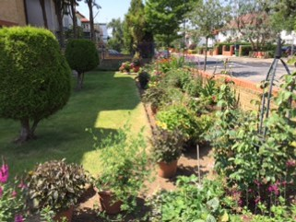
Creative Gardens Competition Entry Form 2019
(Entries must be submitted no later than Friday 10th May 2019 if you wish to receive an EARLY BIRD start-up grant)
The FINAL CLOSING DATE for all entries is Friday 28th June 2019

Name(s) of Gardener.……………………………………………………………………………..….

Address………………………………………………………………………………………………….

…………………………………………………………Postcode………………………………………

Tel …………….……………… Mobile …………………………… Email …………………….……

Location address (if different from above) ………………………………..………………………

Type of garden (e.g. communal, shared, small private, large private, balcony, allotment,

other) ..........................................................................................................................................
I/we would like to enter the gardening competition and hereby apply for a grant from
Innisfree towards the cost of preparing the garden. (Vouchers will be provided by Innisfree.)
I/We understand that I/we must supply receipts after purchases have been made.

Signed …………………………………… Signed………………………………………………

Dated ……………………………………. Dated ……………………………………………….

Email your entry to info@innisfree.org.uk
Or by post to Innisfree Housing Association, 190 Iverson Road London NW6 2HL

